Current a/o 27 March 2020

**508 Template Completion by PM and/or Sub-PfM personnel: Voluntary Product Accessibility Template (VPAT) - 2019 Version**

1. Use current version of VPAT form.
   1. Available on Air Force 508 SharePoint @ <https://cs2.eis.af.mil/sites/10440/InfoAcc/Section%20508/Forms/AllItems.aspx?RootFolder=%2Fsites%2F10440%2FInfoAcc%2FSection%20508%2FSection%20508%20Accessibility%20Template&FolderCTID=0x0120009C855A49FDFEAC4DBDAF75D34D2F4BC6&View=%7B594D084C%2D6A0B%2D418F%2DA024%2DAA9DF29AA53C%7D>
2. Page 1 of the VPAT form lists 508 informational/assistance links, as well as, links to testing tools.
3. Fill in information for each item listed in the table on page 1 to provide a summary view of the product and evaluation methods.
   1. “Report Date” explanation: The report date is the date by which the vendor provided you with a VPAT report.  It is the vendor/developer’s responsibility to provide the Air Force with a Sec 508 compliant product.  The developer is responsible for providing you a completed VPAT and/or responses to the Sec 508 template that gets linked from ITIPS to the SAF/CNZA SharePoint site.  You may provide the developer with the current 508 template version for completion.

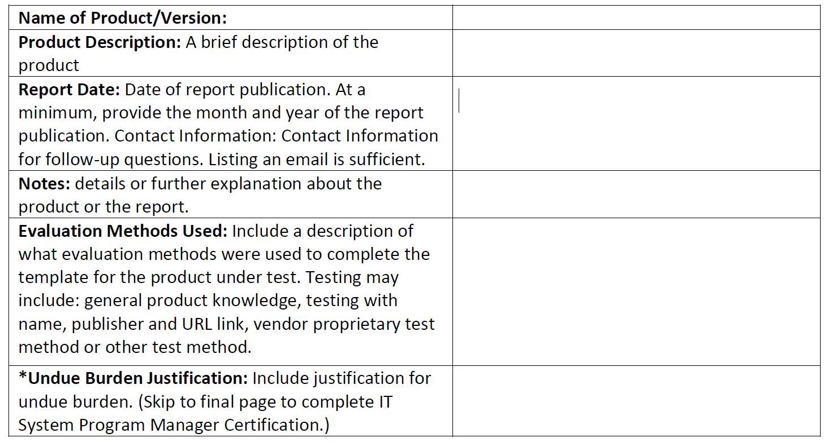

* 1. IF you are requesting “Undue Burden”:
     1. Do NOT skip to final page.
     2. Add appropriate comments to the table.
     3. Complete all steps below in this process to identify and document any/all criteria items.
        + 1. For all items that Supports, Partially Supports or Not Applicable and how.
          2. For all items where Undue Burden apply.

1. Tables on pages 2-7 completion:
   1. Analyze/evaluate 508 compliance – For each VPAT listed “Criteria” item, use the Web Content Accessibility Guidelines (WCAG) link on VPAT page 1.
      1. Use the para. number listed for each VPAT Criteria item then go to same para. number in the WCAG.

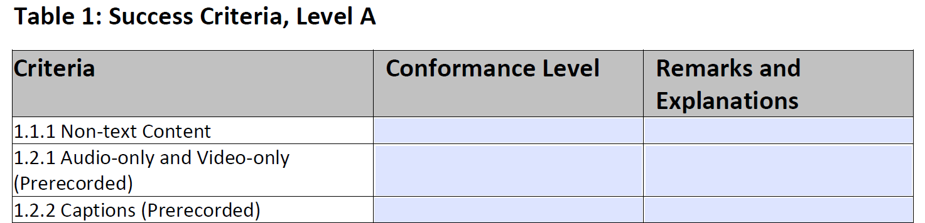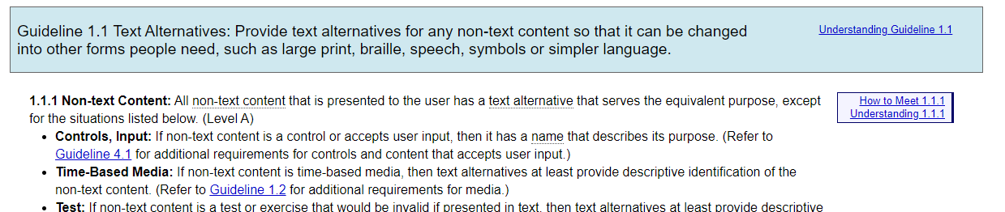

* + 1. Within each section/para. in the WCAG there is description/applicability for each Criteria item.
    2. Also within each section/para. in the WCAG there are 3 links to assist with each Criteria item



* 1. Complete each Criteria item’s “Conformance Level” of the VPAT.
     1. Determine Conformance Level by using the “Analyze/evaluate...”step above.
     2. Complete the Confirmation Level column-cell for each VPAT item using the terms described on VPAT page 2.

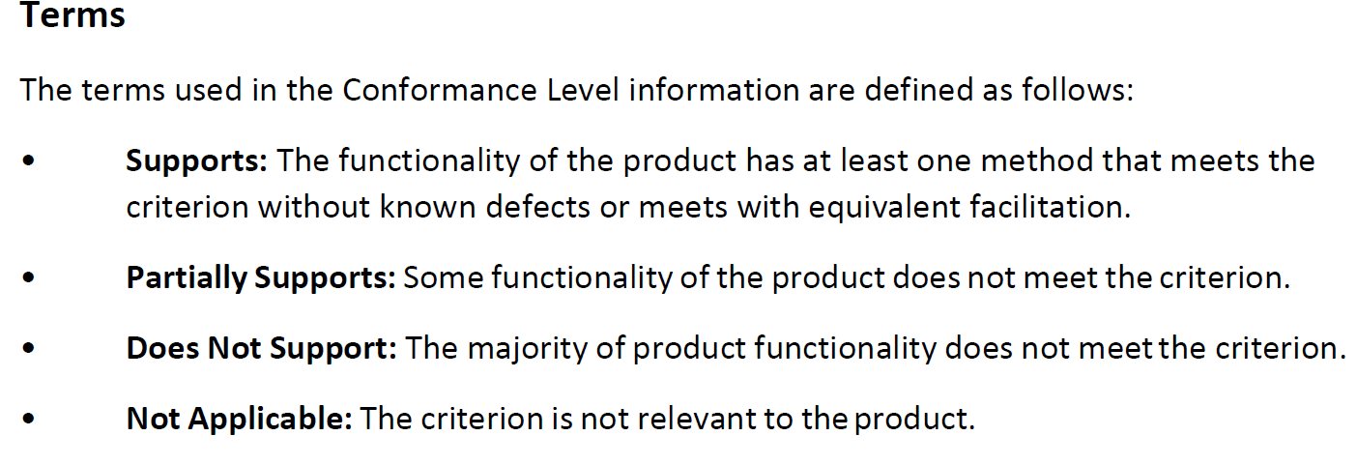

* 1. Complete each Criteria item’s “Remarks and Explanation” of the VPAT.
     1. Enter appropriate Remark and Explanation column-cell for each VPAT item.
        1. These remarks can include information regarding the testing of a given criteria, information on application dependencies to support accessibility, information on how the customer can find more information about accessibility issues, known workarounds for accessibility issues, or timelines planned to get to “Supports” confirmation level.
        2. “Supports” - List exactly **what** features of the product **do** meet and describe **how** they are used to support the Criteria.
        3. “Partially Supports” - List exactly **what** features of the product **do** meet and describe **how** they are used to support the Criteria. **– AND –** List exactly **what** parts of the product **do not** meet and describe **how** they fail to support the Criteria.
        4. **“Does Not Support”** - Describe exactly **how** the product does not support the Criteria.
        5. “Not Applicable” - Describe exactly **why** the criteria is not applicable to the product.

1. PM and PfM completes the Certification blocks and digitally signs on page 8.
2. PM uploads the completed VPAT into ITIPS.
3. PM notifies SAF 508 Coordinator via their org box @ [usaf.pentagon.saf-cn.mbx.af-section-508@mail.mil](mailto:usaf.pentagon.saf-cn.mbx.af-section-508@mail.mil)
4. If “Undue Burden” is submitted - the “Undue Burden Approving Official” reviews, and IF approved, digitally signs that area.
   1. NOTE: SAF 508 Coordinator is the “Undue Burden Approving Official”.
   2. The PM must describe/provide required information in accordance with “Undue Burden Finding” on page 1 of the VPAT.
      1. PM creates a separate Word document addressing EACH criteria item that creates an undue burden.
         1. Must be detailed justification and address areas listed in “Undue Burden Finding” items 1-6 on page 1.
      2. PM uploads the Word document into ITIPS.
      3. PM notifies SAF 508 Coordinator via their org box @ [usaf.pentagon.saf-cn.mbx.af-section-508@mail.mil](mailto:usaf.pentagon.saf-cn.mbx.af-section-508@mail.mil)